GIT AND GITHUB ASSESSMENTS

Section 0

1. mkdir project_dir

cd project_dir

1. git init
2. touch index.html
3. git status
4. git add index.html
5. git commit -m “ first commit”
6. make changes

touch info.txt

1. git status
2. touch .gitignore

open .gitignore file and type .*txt

1. git status
2. git add index.html & git commit
3. git log
4. make changes in index.html
5. git reset –soft HEAD~1
6. make changes in index.html
7. git add index.html
8. git revert HEAD
9. git config –global alias.my-add add
10. git my-add index.html
11. git revert HEAD

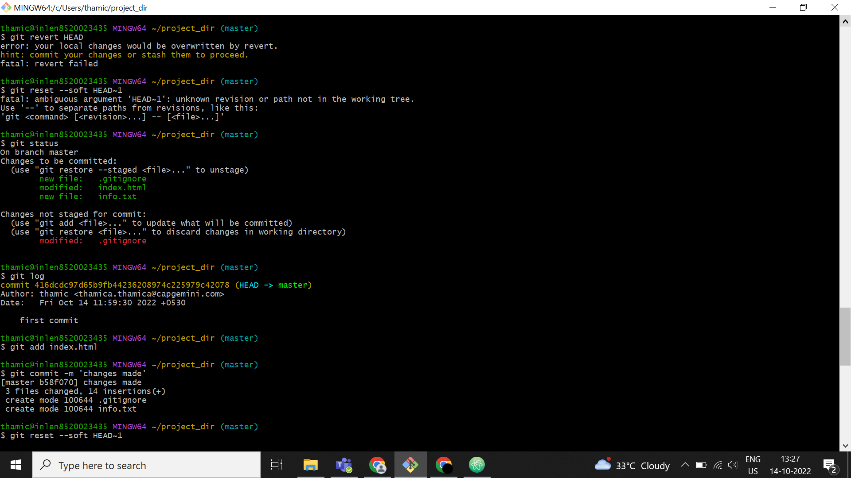

GIT BRANCHING

Section 1

1. Take a backup of all assignments
2. mkdir Assignments & cd Assignments
3. touch README.txt
4. git add README.txt & git commit README.txt -m “first commit”
5. git branch html-assignments
6. git checkout html-assignments
7. copy all assignments (htmlfiles.html)
8. git add htmlfiles.html & git commit
9. make change into htmlfiles.html
10. git add htmlfiles.html & git commit -m “made changes”
11. git checkout master
12. make changes in README.txt

git add README.txt & git commit -m”made changes”

1. git checkout html-assignments
2. make changes in htmlfiles.html
3. git add htmlfiles.html & git commit -m “ made changes”
4. git checkout master
5. git merge html-assignments
6. git branch -d html-assignments

Section 2

1. git branch css-assignments
2. git checkout css-assignments
3. copy all assignments (cssfiles.css)
4. git add cssfiles.css & git commit
5. make change into README.txt
6. git add README.txt & git commit -m “made changes in line 1”
7. git checkout master
8. make changes in README.txt

git add README.txt & git commit -m”made changes in line 3”

1. git checkout css-assignments
2. make changes in cssfiles.css
3. git add cssfiles.css & git commit -m “ made changes”
4. git checkout master
5. git merge css-assignments
6. git branch -d css-assignments

Section 3

1. git branch js-assignments
2. git checkout js-assignments
3. copy all assignments (javaAss.js)
4. git add javaAss.js & git commit
5. make change into README.txt
6. git add README.txt & git commit -m “made changes in line 1”
7. git checkout master
8. make changes in README.txt

git add README.txt & git commit -m”made changes in line 3”

1. git checkout js-assignments
2. make changes in javaAss.js
3. git add javaAss.js & git commit -m “ made changes”
4. git checkout master
5. git merge js-assignments
6. git branch -d js-assignments

GIT REMOTING

Section 4

1. Created a github account
2. Login on into
3. Created a new repo “freshersbatch-oct16”
4. cd Assignments

git add htmlfiles.html

git commit html.files -m “ committing a sample file”

git remote add origin “url”

git push -u origin master

Section 5



